# Snowflake

* Alteryx: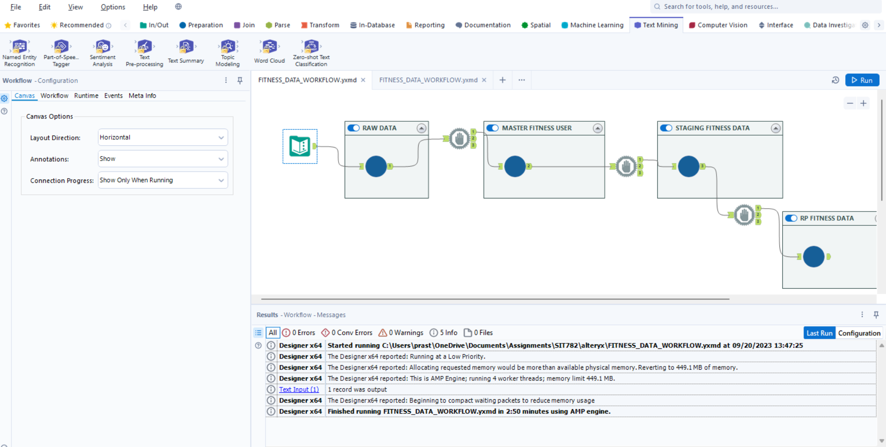
* “Select * from RW_FITNESS_DATA."rw_fitness_data";”

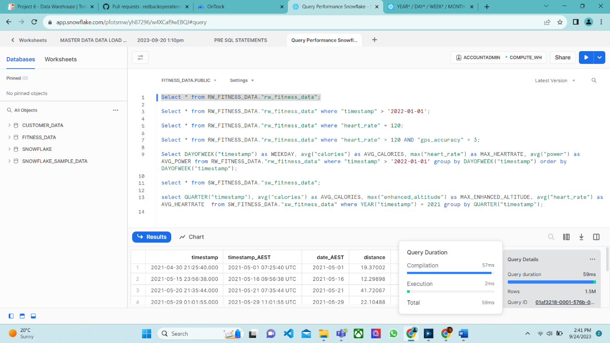

* “Select * from RW_FITNESS_DATA."rw_fitness_data" where "timestamp" > '2022-01-01';”

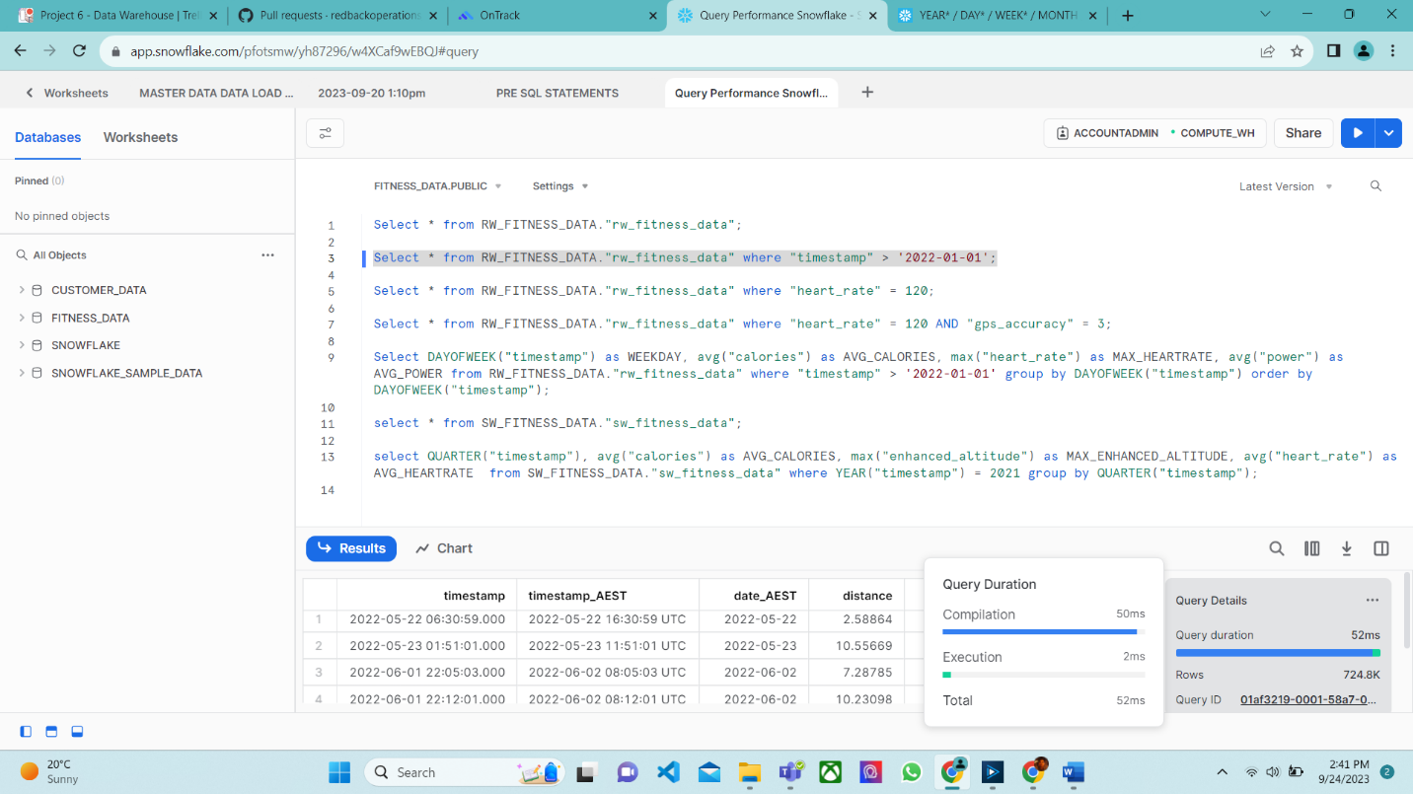

* “Select * from RW_FITNESS_DATA."rw_fitness_data" where "heart_rate" = 120;”

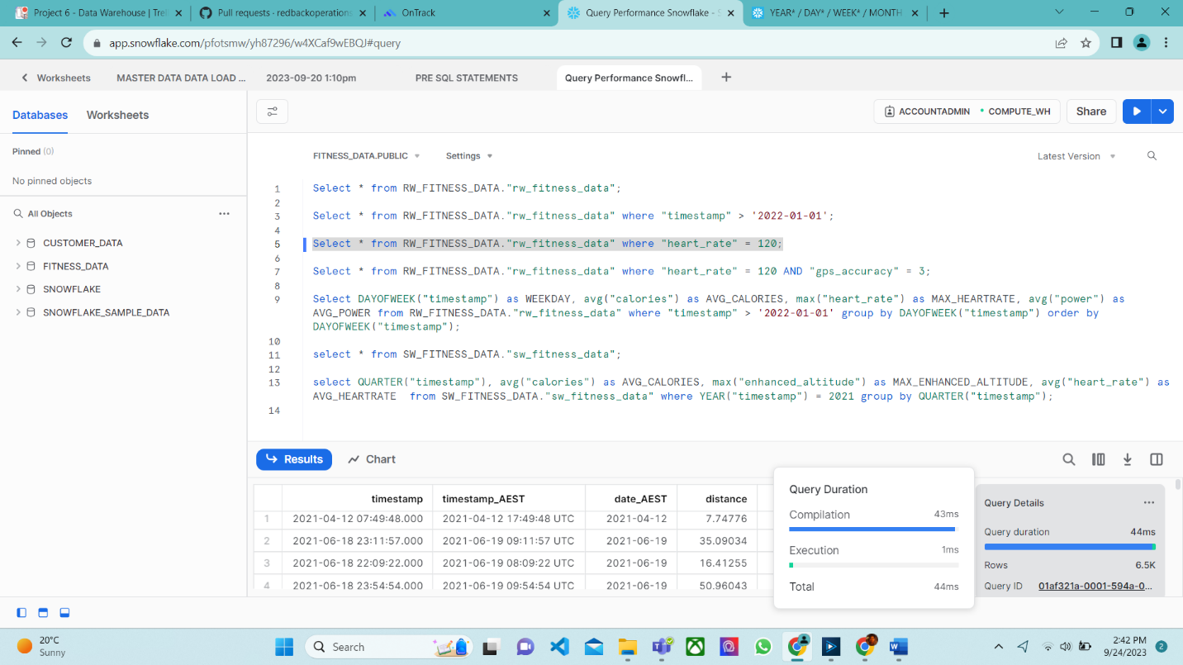

* “Select * from RW_FITNESS_DATA."rw_fitness_data" where "heart_rate" = 120 AND "gps_accuracy" = 3;”

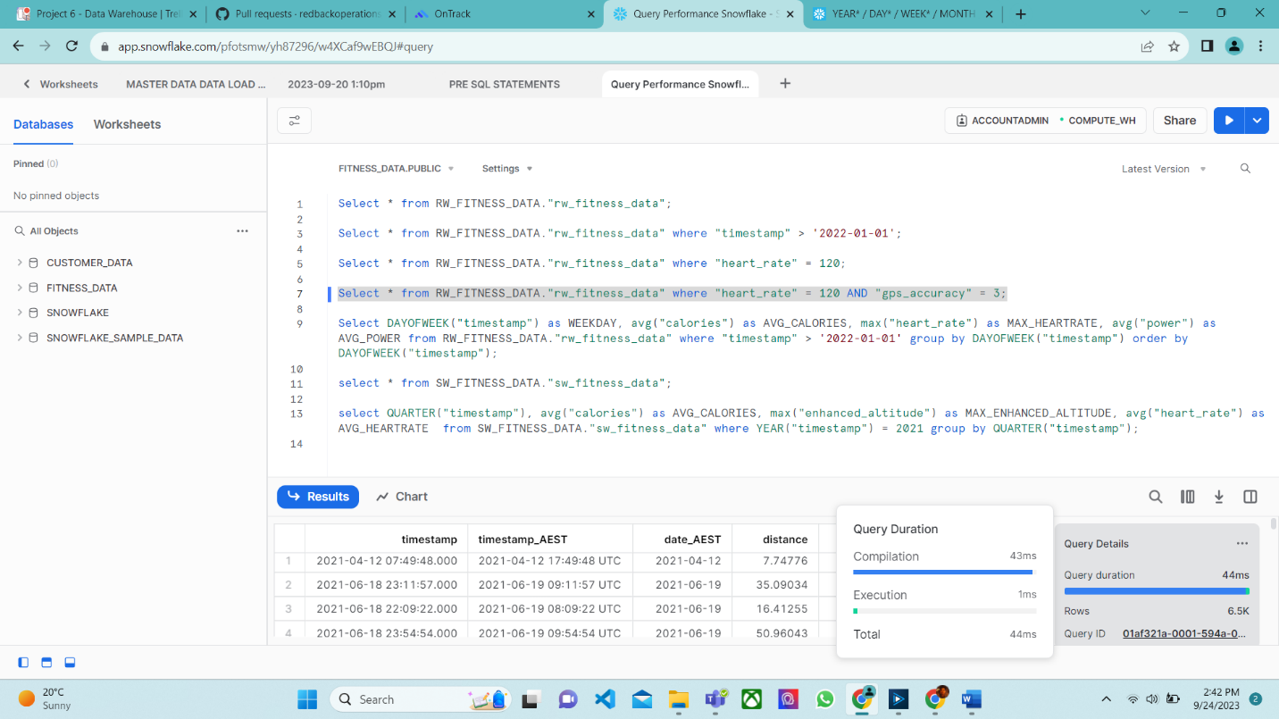

* “Select DAYOFWEEK("timestamp") as WEEKDAY, avg("calories") as AVG_CALORIES, max("heart_rate") as MAX_HEARTRATE, avg("power") as AVG_POWER from RW_FITNESS_DATA."rw_fitness_data" where "timestamp" > '2022-01-01' group by DAYOFWEEK("timestamp") order by DAYOFWEEK("timestamp");”

* “select * from SW_FITNESS_DATA."sw_fitness_data";”

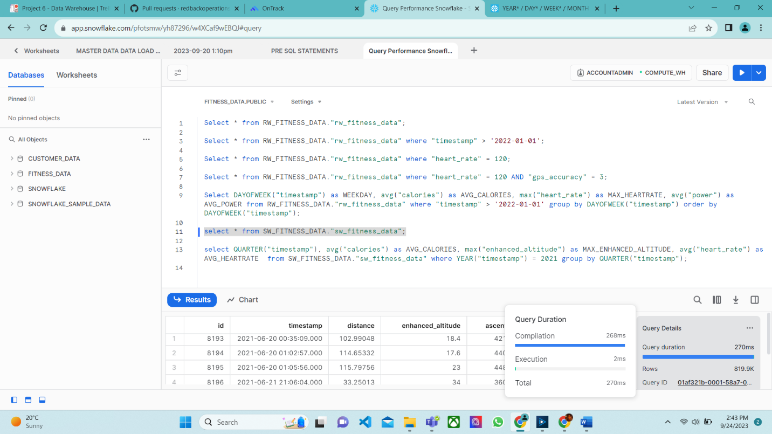

* “select QUARTER("timestamp"), avg("calories") as AVG_CALORIES, max("enhanced_altitude") as MAX_ENHANCED_ALTITUDE, avg("heart_rate") as AVG_HEARTRATE from SW_FITNESS_DATA."sw_fitness_data" where YEAR("timestamp") = 2021 group by QUARTER("timestamp");”A screenshot of a computer

  Description automatically generated

# SQL SERVER

* Alteryx:A screenshot of a computer

  Description automatically generated
* “Select * from rw_data.dbo.rw_fitness_data”;”

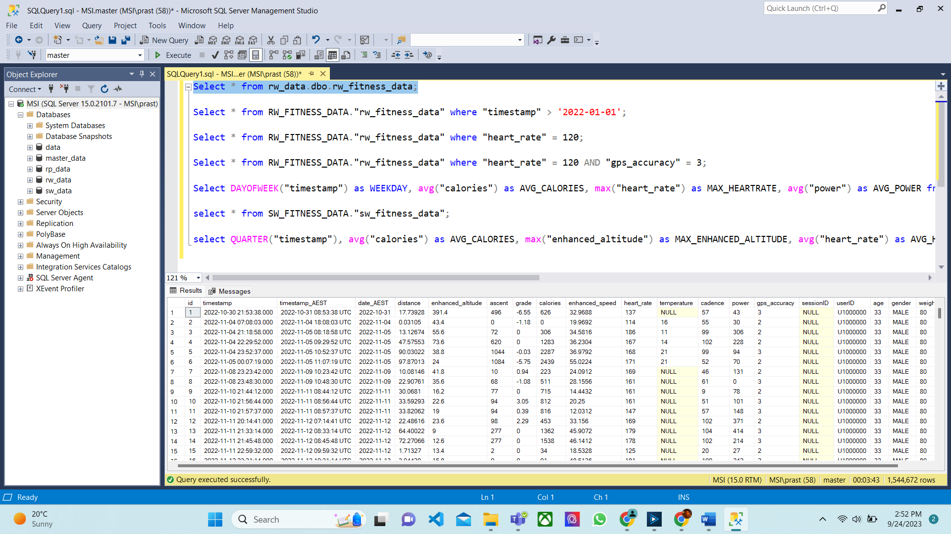

* “Select * from rw_data.dbo.rw_fitness_data where timestamp > '2022-01-01';”

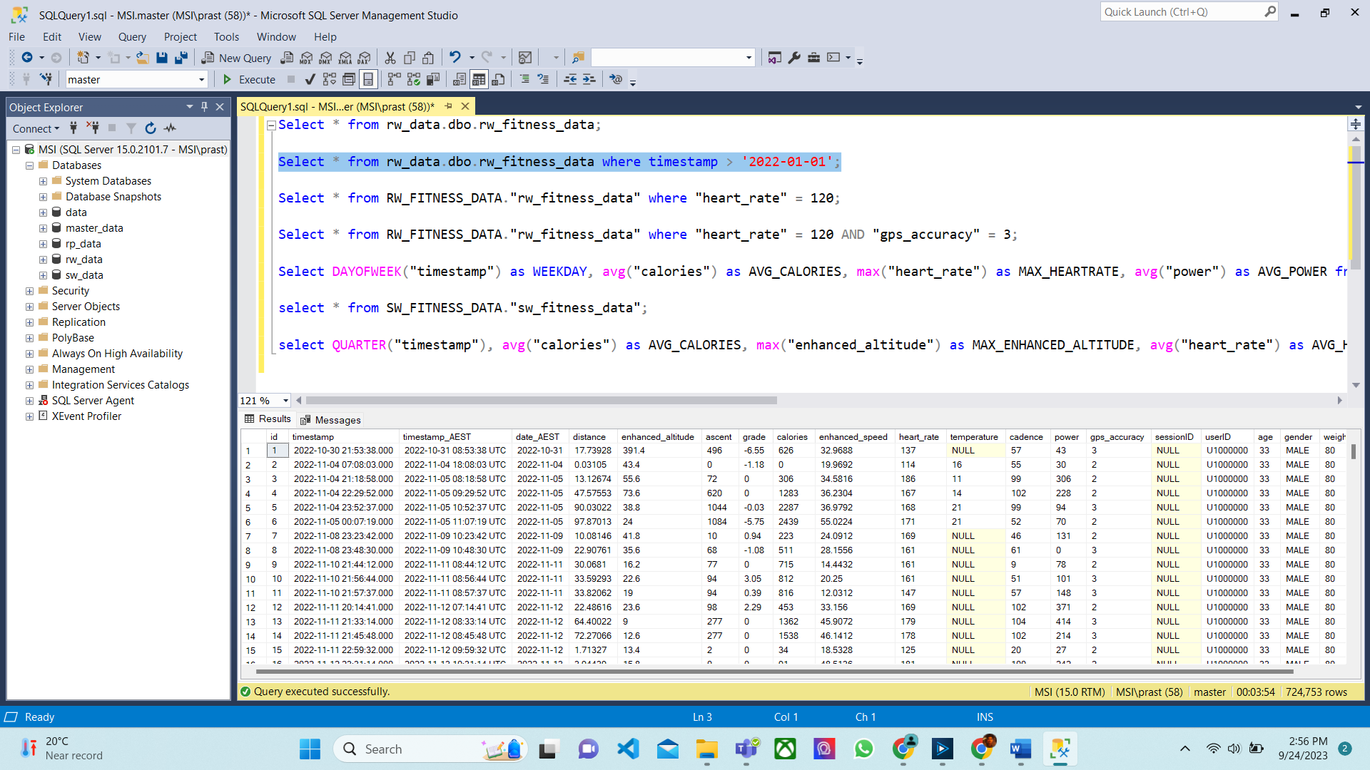

* “Select * from rw_data.dbo.rw_fitness_data where heart_rate = 120;”

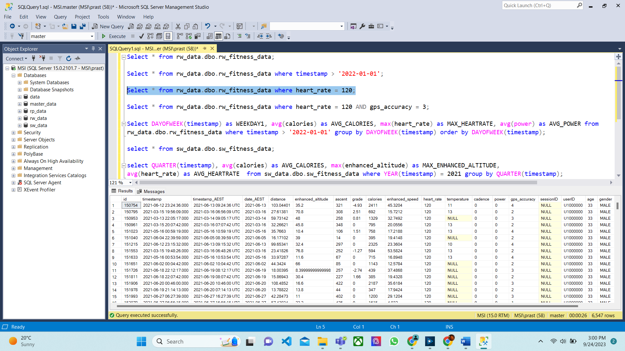

* “Select * from rw_data.dbo.rw_fitness_data where heart_rate = 120 AND gps_accuracy = 3;”

* “Select DATEPART(dw, timestamp) as WEEKDAY1, avg(calories) as AVG_CALORIES, max(heart_rate) as MAX_HEARTRATE, avg(power) as AVG_POWER from

rw_data.dbo.rw_fitness_data where timestamp > '2022-01-01' group by DATEPART(dw, timestamp) order by DATEPART(dw, timestamp);”

* “select * from sw_data.dbo.sw_fitness_data;”

* “select DATEPART(Q, timestamp), avg(calories) as AVG_CALORIES, max(enhanced_altitude) as MAX_ENHANCED_ALTITUDE,

avg(heart_rate) as AVG_HEARTRATE from sw_data.dbo.sw_fitness_data where YEAR(timestamp) = 2021 group by DATEPART(Q, timestamp);”

# Conclusion

Based on our comparative analysis of Snowflake and Microsoft SQL Server (MSSQL) performance with the above evidences, it is evident that Snowflake outperformed MSSQL significantly in terms of query processing and execution, resulting in a notable reduction of around 3 minutes in the Alteryx workflow runtime. This outcome strongly suggests that Snowflake is a more efficient and faster option for data warehousing in our specific use case. As organizations increasingly rely on timely data insights for informed decision-making, the superior performance of Snowflake can translate into enhanced productivity, better analytics, and ultimately a competitive advantage. Therefore, adopting Snowflake as our data warehousing solution appears to be a prudent choice, ensuring optimal data processing and analysis capabilities for our organization.